CSS GENDER STUDIES
T2QA
The Question Answers
Topic 2 · Feminist Theories and Practice — every past question answered as a model
WHAT THIS DOCUMENT GIVES YOU
◆ All six CSS questions on Topic 2 (2016–2025) and the two short notes (2019, 2024), answered in full
◆ An answer map for every answer — each branch a numbered heading
◆ The command words and limbs of every question decoded
◆ Model answers of 1,000–1,300 words (notes 550–650) with evidence inside every heading
◆ Why each answer scores — what the examiner rewards
Federal Public Service Commission · CSS Competitive Examination · Optional paper, 100 marks
Written for CE-2027 onwards · Record: CE-2016 to CE-2026 · Facts current to September 2026

Contents
HOW TO BUILD THE CONTENTS
The contents list below fills itself in. When Word asks "This document contains fields that may refer to other files. Update the fields?", click Yes.
If it does not ask: right-click the grey contents area → Update Field → Update entire table → OK. On a Mac, Control-click the same area. Or press Ctrl + A, then F9 (Windows), to update every field at once. Repeat after any edit, before you export to PDF.

Right-click here and choose Update Field to build the contents.

How to Use These Answers

What is in this document
Table 1 · The questions answered in this document (T2).
No. | Question | Year · Q | Family
1 | What is feminism? In what way is Radical Feminism different from Socialist Feminism? | CSS 2016 · Q7 | What is feminism; schools of feminism compared; Radical feminism; Marxist / socialist feminism
2 | What type(s) of feminism can elevate the socio-cultural, economic and political status of women in Pakistan? | CSS 2018 · Q4 | Which feminism suits Pakistan
3 | Postmodern Feminism | CSS 2019 · Q8(b) | Postmodern feminism
4 | Marxist feminism is a philosophical variant of feminism that incorporates and extends Marxist theory and analyzes the ways in which women ar… | CSS 2021 · Q4 | Marxist / socialist feminism
5 | Psychoanalytic feminism is a theory of oppression which asserts that men have an inherent psychological need to subjugate women. Give a deta… | CSS 2021 · Q5 | Psychoanalytic feminism
6 | Describe any two Western schools of thought about feminism in detail. | CSS 2022 · Q3 | What is feminism; schools of feminism compared
7 | Radical Feminism | CSS 2024 · Q8(b) | Radical feminism
8 | Give a detailed analysis of the intersectionality of gender with other social identities. | CSS 2025 · Q6 | Intersectionality

How every answer is built
1. The question, exactly as set, with its year and number.
2. The answer map — a mind map whose centre states what the question asks, part by part. Every branch is one numbered heading of the answer, and every point on it is a short phrase that makes complete sense on its own — so the map alone tells the examiner the whole argument. Draw a quick version in the margin of your answer book before you write.
3. Decoding the question — the command words and what each part demands.
4. The model answer — 1,000 to 1,300 words (550 to 650 for a short note), the length a strong candidate can write in about thirty minutes. It is built in two levels: main headings 1, 2, 3… taken from the question's own words, and sub-headings i), ii), iii)… under them. The introduction always has a simple definition, the background and the argument. Each sub-heading answers one point in a short paragraph with the key words in bold. Every answer has at least one figure besides the answer map (a comparison, flow, cycle, pyramid or Venn diagram), often a table as well, a Pakistan angle, the criticisms and a balanced conclusion.
5. Why this answer scores — what the examiner rewards in it.
EXAMINER'S EYE · THEORY QUESTIONS NEED PAKISTAN TOO
Topic 2 is the most theoretical topic in the paper, and many candidates answer it like a Western textbook — names, dates and nothing else. The examiner rewards the candidate who applies each school: every answer below ends its analysis with a Pakistan angle, and several test the question's own wording (for example, the word "inherent" in 2021). Notice also how the same thinkers — Millett, Hartmann, Chodorow, Crenshaw — are re-used under different headings to fit each question.

Answer 1 · What Is Feminism? Radical versus Socialist Feminism (CSS 2016)
AT A GLANCE · CSS 2016 · Q7 · 20 MARKS
What is feminism? In what way is Radical Feminism different from Socialist Feminism?

The answer map
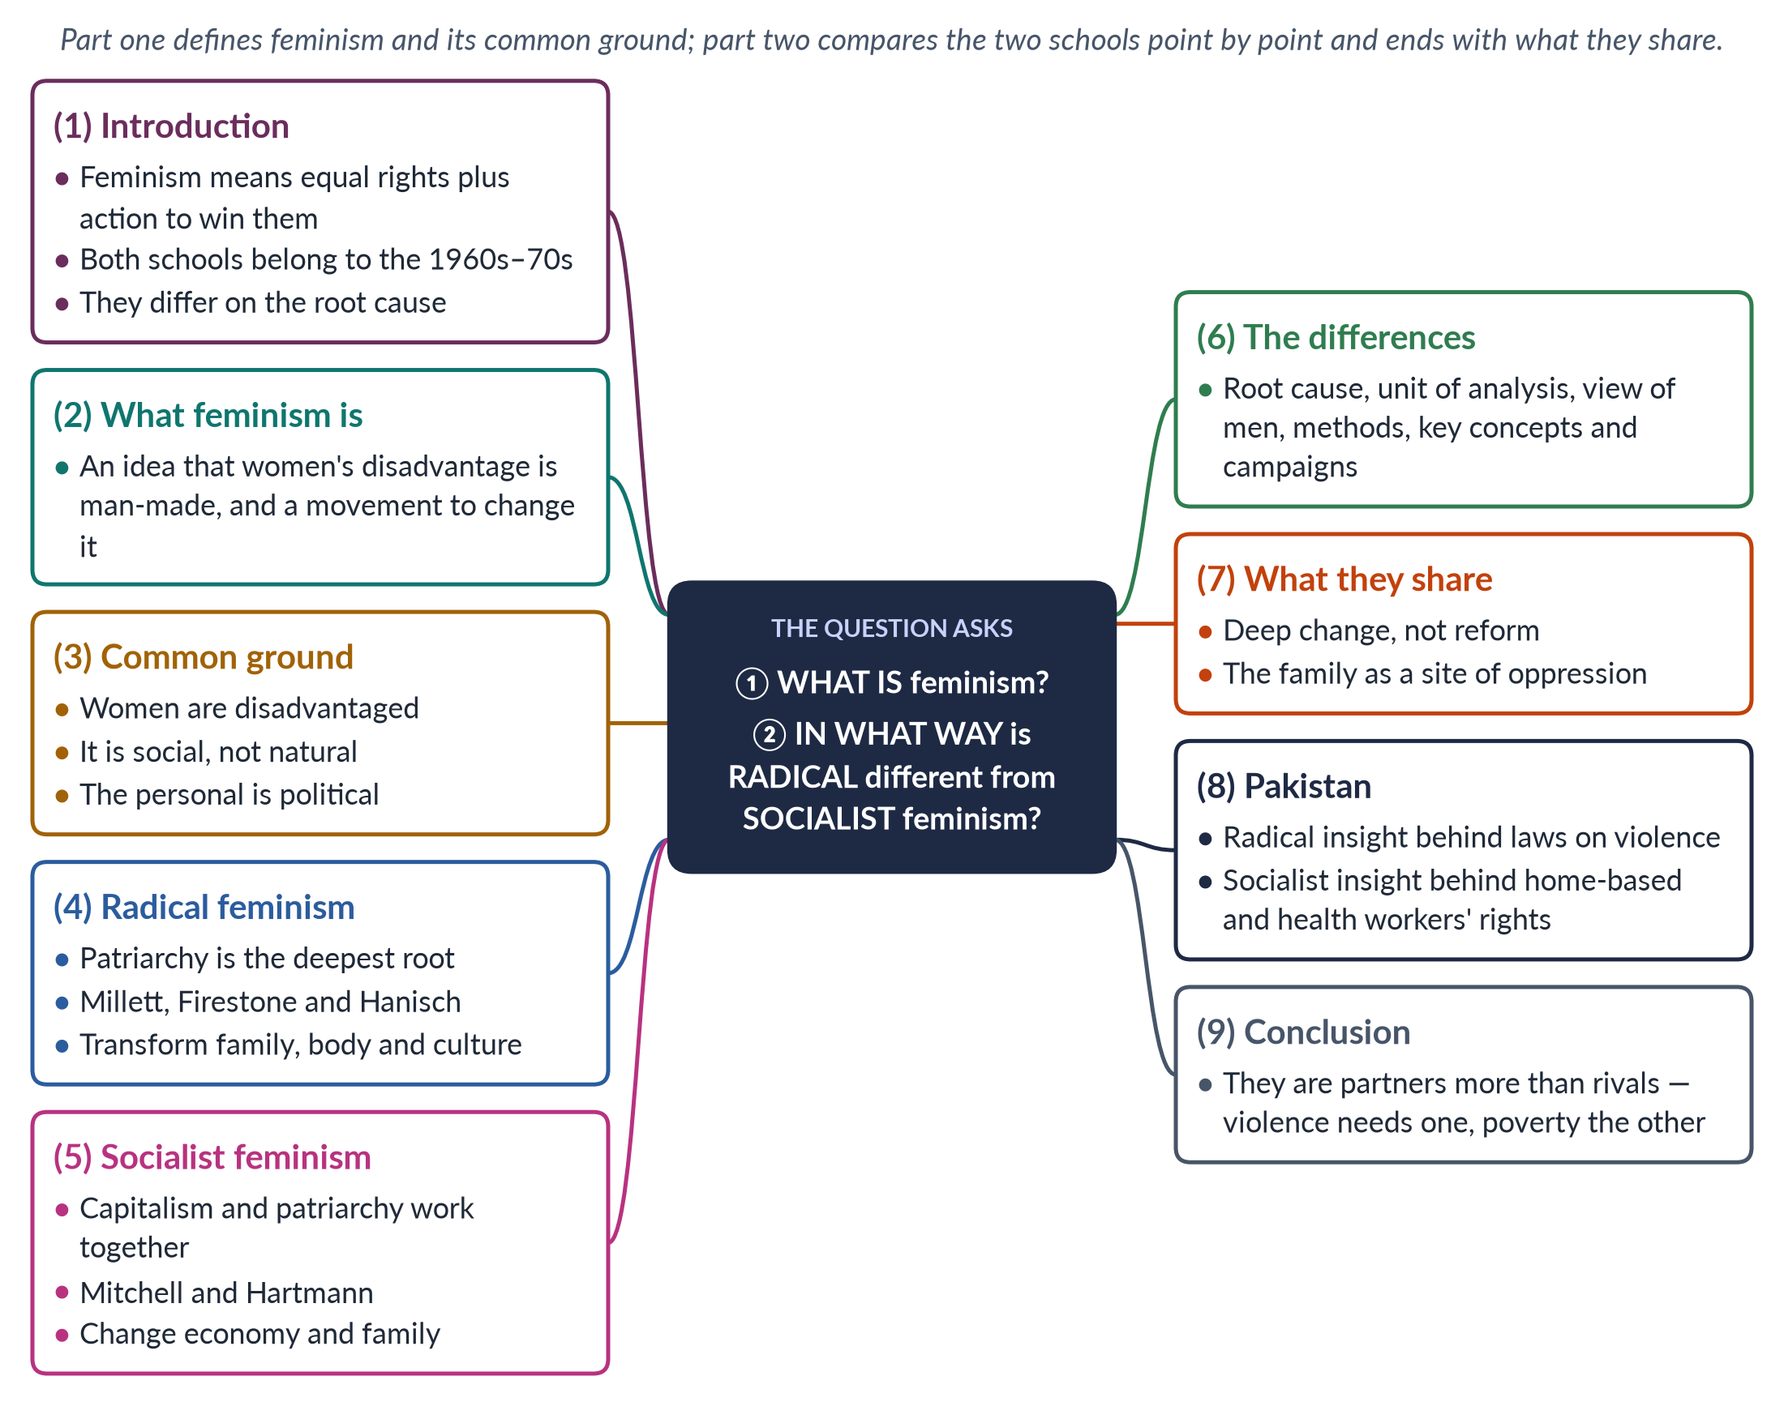
Figure 1 · The answer map: every branch is one numbered heading of the model answer below.

Decoding the question
The question has two parts. "What is feminism?" asks for a definition — a simple one of your own, a quoted one, and a short account of what all feminists share. "In what way is … different" asks for a comparison: the examiner wants points of difference, set side by side, not two separate essays. The best answers also note what the two schools share, because a difference only means something against a common background.

The model answer

1. Introduction

i) Definition
Feminism is the belief that women and men should have equal rights, dignity and chances, together with organised action to achieve this.

ii) The two schools
Radical and socialist feminism both grew in the late 1960s and 1970s, the "second wave". Both want deep change rather than mere legal reform.

iii) The argument
They differ on the root cause. For radical feminists the root is patriarchy alone; for socialist feminists it is patriarchy and capitalism working together. From this one difference, all the others follow.

2. What feminism is

i) A theory and a practice
Feminism is both an idea and a movement. As an idea, it says that women as a group are disadvantaged and that this disadvantage is made by society, not fixed by nature. As a movement, it organises to change that situation — through writing, protest, law and new ways of living.

ii) Two definitions
bell hooks (2000) called feminism "a movement to end sexism, sexist exploitation, and oppression" — its target is sexism, not men. The South Asian scholars Kamla Bhasin and Nighat Said Khan (1986) defined it as "an awareness of women's oppression and exploitation in society, at work and within the family, and conscious action by women and men to change this situation".

iii) Roots
The word came from France (Hubertine Auclert, 1882), but the ideas are older and not only Western: Tarabai Shinde (1882) and Begum Rokeya (1905) argued for women's dignity in South Asia.

3. What all feminists share

i) Five common claims
All schools accept that: (1) women are disadvantaged; (2) this is social, not natural; (3) the personal is political; (4) women's experience is valid knowledge; and (5) change is possible.

ii) Where they part
They disagree on the cause of oppression, where it happens, and the remedy. Liberal feminists blame unequal laws and want reform; Marxists blame capitalism; psychoanalytic feminists look to early childhood. The radical and socialist schools are the two great "transformation" schools of the second wave, and their quarrel is about the root.

4. Radical feminism

i) Meaning
"Radical" comes from the Latin radix, root. Radical feminists hold that patriarchy — male power over women — is the oldest and deepest form of oppression, found in every society and every class.

ii) Thinkers
Kate Millett (Sexual Politics, 1970) showed that relations between the sexes are power relations. Shulamith Firestone (The Dialectic of Sex, 1970) traced oppression to reproduction and called women a "sex class". Carol Hanisch's essay "The Personal Is Political" (1970) defended consciousness-raising groups.

iii) Where and how
Its main sites are the family, sexuality, the body and violence. Its remedy is to transform culture and family at the root — above all, to end men's control of women's bodies.

5. Socialist feminism

i) Meaning
Socialist feminism holds that women are oppressed by two linked systems: capitalism, which exploits workers, and patriarchy, which gives men power over women. Zillah Eisenstein (1979) called the combined system "capitalist patriarchy".

ii) Thinkers
Juliet Mitchell (Woman's Estate, 1971) named four structures: production, reproduction, sexuality and the socialisation of children. Heidi Hartmann ("The Unhappy Marriage of Marxism and Feminism", 1979) called Marxism "sex-blind" and proposed dual-systems theory.

iii) Where and how
Its sites are paid work and the family together. Its remedy is to change both: equal pay, public childcare, shared housework and workers' rights.

6. The differences
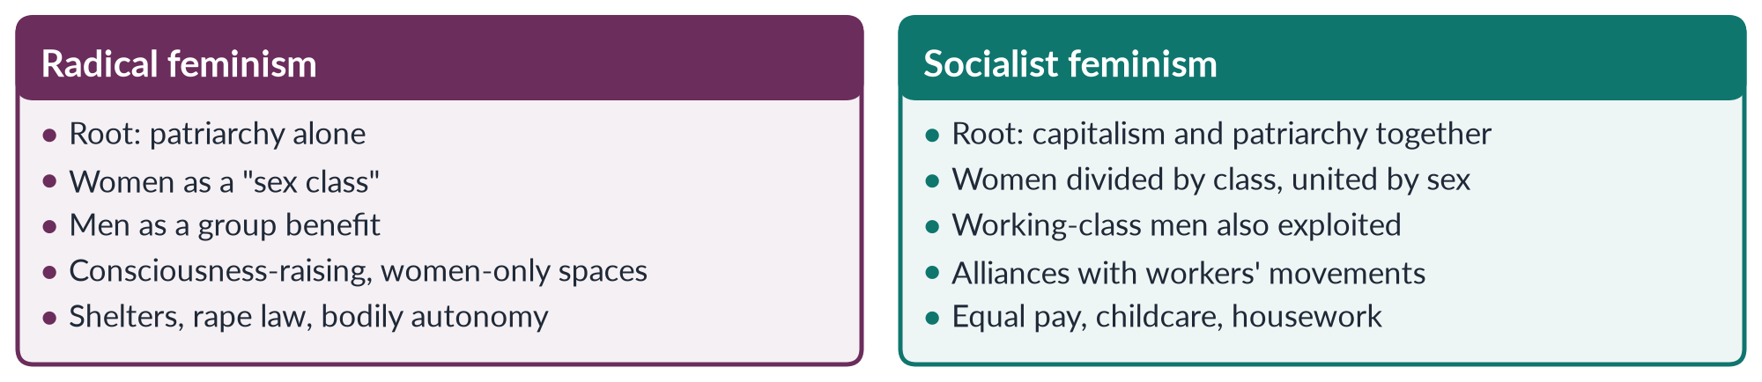
Figure 2 · Radical and socialist feminism at a glance.

i) The root cause
Radical: patriarchy came first and would survive the end of capitalism. Socialist: ending capitalism alone would not free women, but neither would ending patriarchy alone — both systems must change.

ii) The unit of analysis
Radical feminism studies sex: women form one class. Socialist feminism studies sex and class together: a factory owner's wife and a factory worker's wife share some oppression but not all.

iii) The view of men
Radicals see men as a group as the beneficiaries of patriarchy. Socialists see working-class men as also exploited, and therefore as possible allies.

iv) Key concepts
Radical: sexual politics, sex class, the personal is political. Socialist: dual systems, family wage, double burden, social reproduction.

v) Methods and campaigns
Radical feminism built rape crisis centres and shelters (the first modern shelter opened in London in 1971) and campaigned on bodily autonomy. Socialist feminism campaigned on equal pay, childcare and wages for housework.

vi) Main weakness
Radicals are criticised for ignoring class and race: bell hooks said they spoke for white, middle-class women. Socialists are criticised for underplaying violence and sexuality, which cannot be explained by money alone.

vii) One example, two readings
Take a Pakistani woman beaten by her husband for asking to keep her wages. A radical reading sees male control of her body and choices — patriarchy at work in the home. A socialist reading adds that her economic dependence, low wages and unpaid housework make it hard for her to leave. Both are true; each school sees one side more clearly.

7. What they share

i) Common ground
Both reject liberal reformism as too shallow. Both see the family as a site of oppression. Both accept that the personal is political. The difference is one of emphasis — the body and violence for radicals, work and money for socialists.

ii) A shared history
Many socialist feminists began as radicals, and many radicals borrowed Marx's language — Firestone called women a "class" and spoke of seizing the "means of reproduction". The two schools grew from the same movement and the same consciousness-raising groups.

8. The Pakistan angle

i) Radical insight
The Women's Action Forum's campaign against the Hudood Ordinances (1979) and later laws on honour killing (2016) and rape (2021) reflect the radical insight that violence controls women.

ii) Socialist insight
Most employed Pakistani women work in agriculture, much of it unpaid; female labour-force participation is only 24.4% (LFS 2024–25). The struggles of Lady Health Workers and the Sindh Home-Based Workers Act (2018) are socialist-feminist in spirit.

9. Conclusion
Feminism is one belief with many explanations. Radical feminism sees patriarchy as the single root and fights it in the family and the body; socialist feminism sees patriarchy and capitalism as partners and fights them in the family and the economy. For a country like Pakistan, the two are partners more than rivals: the first explains the violence women face, the second the poverty that traps them.

Why this answer scores
- Both parts are answered: a definition with two quoted versions, then a point-by-point comparison.
- The introduction gives a definition, the background and a one-line thesis of the difference.
- Differences are set out under six sub-headings, not as two separate essays.
- The compare figure lets the examiner see the contrast at a glance.
- What they share and a Pakistan angle raise the answer above a textbook summary.

Answer 2 · Which Feminism Can Raise Women's Status in Pakistan? (CSS 2018)
AT A GLANCE · CSS 2018 · Q4 · 20 MARKS
What type(s) of feminism can elevate the socio-cultural, economic and political status of women in Pakistan?

The answer map
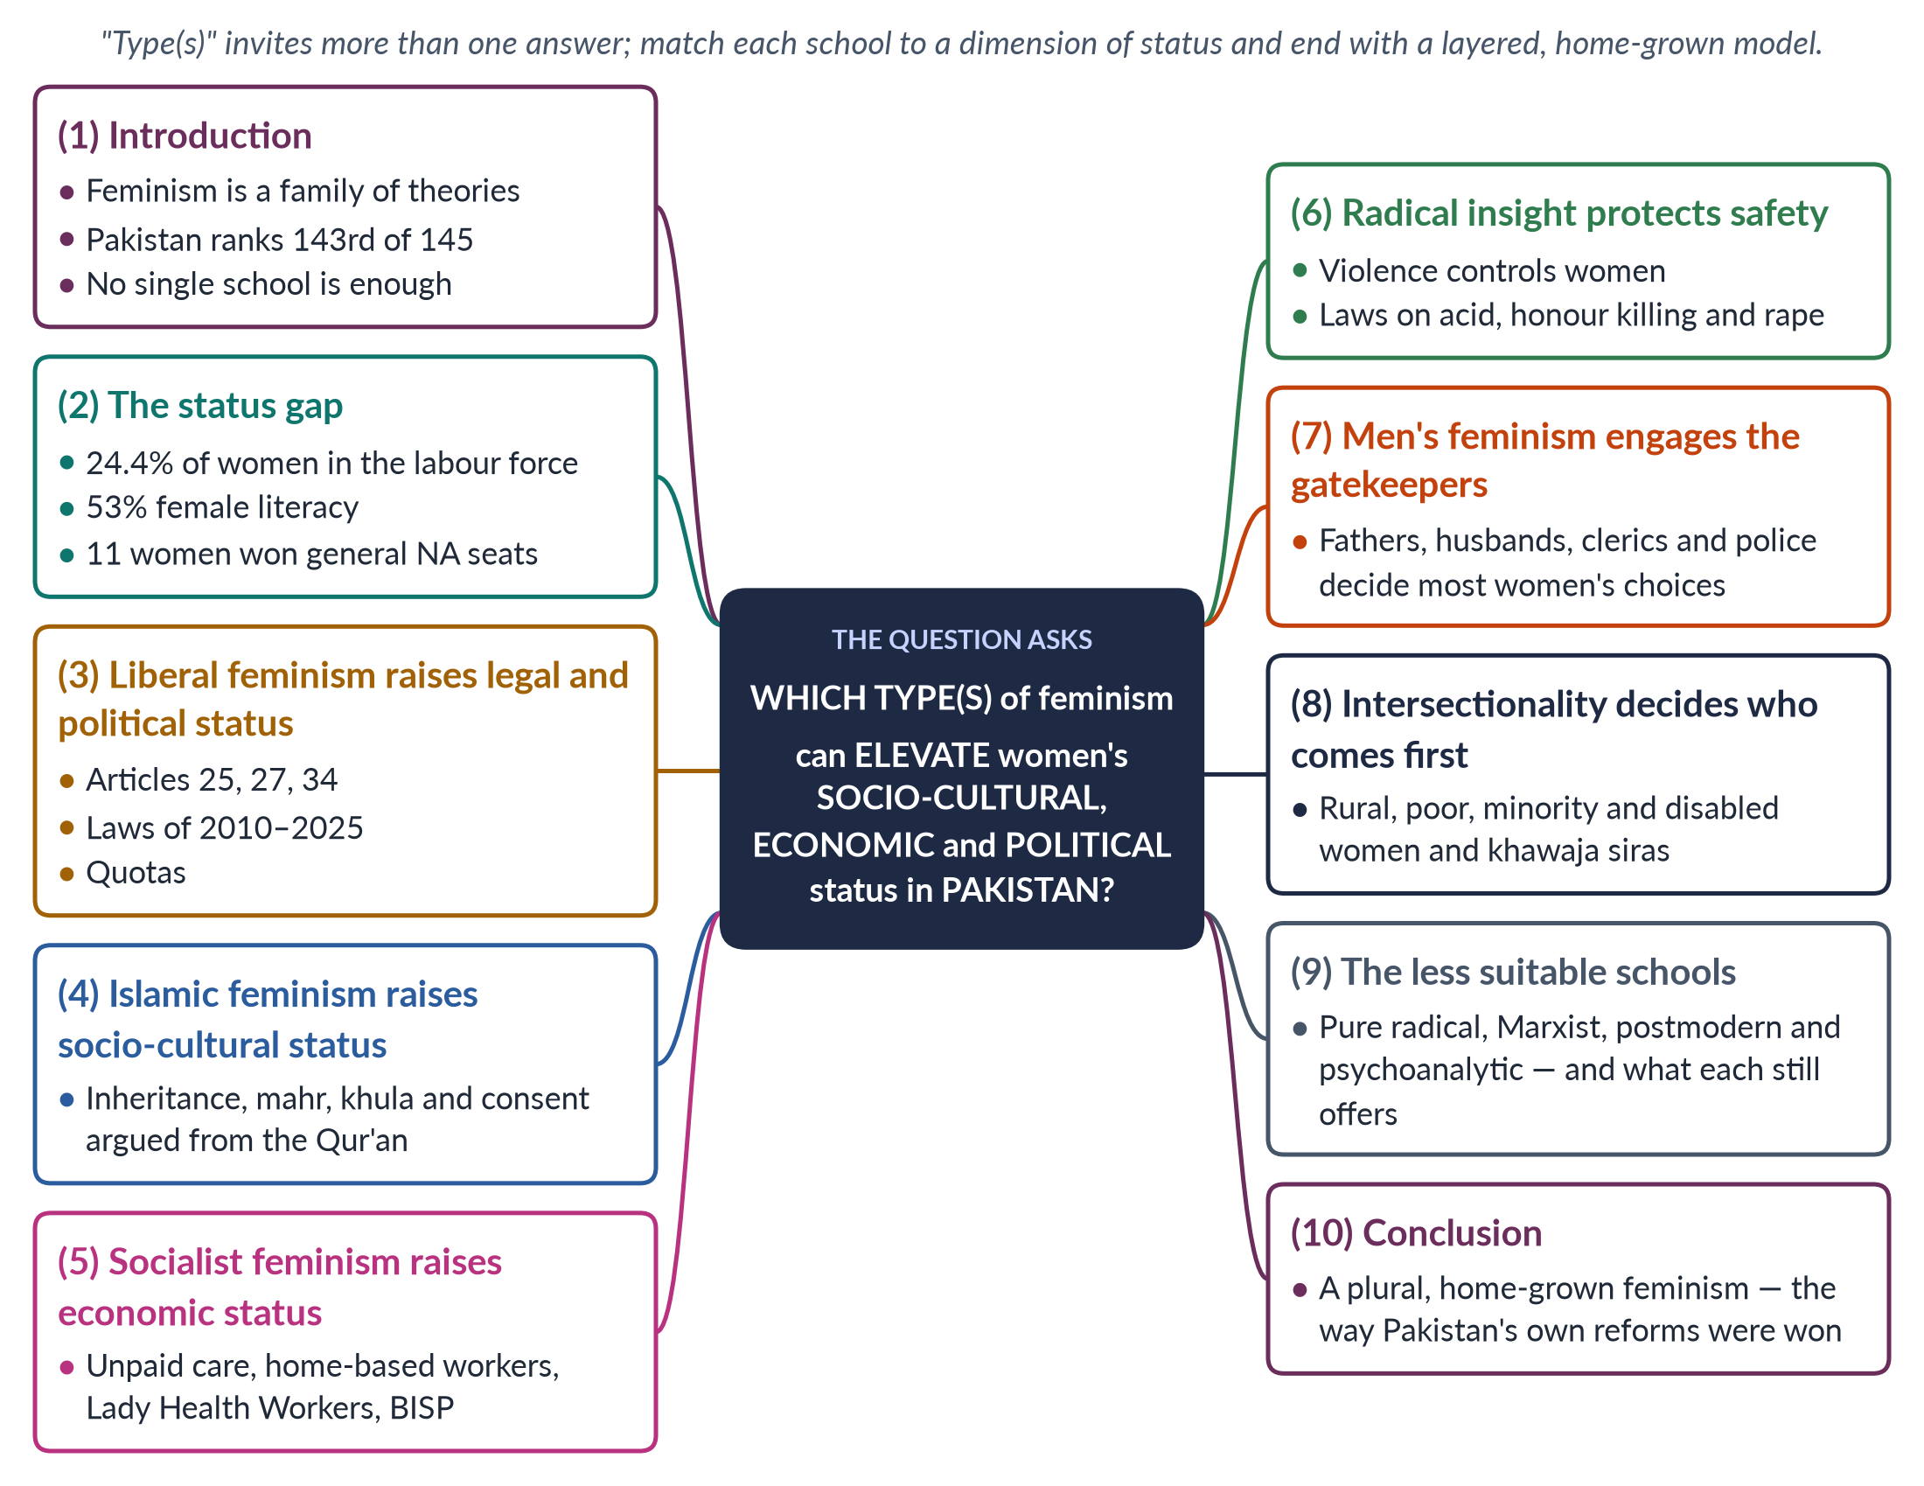
Figure 3 · The answer map: every branch is one numbered heading of the model answer below.

Decoding the question
"What type(s)" signals that the examiner accepts — even expects — more than one school. The question names three dimensions of status: socio-cultural, economic and political. The best answer matches each school to a dimension, gives Pakistani evidence for each, admits the limits of each, and ends with a combined model. The trap is to write a history of the women's movement (that is a different question) or to back one school and dismiss the rest.

The model answer

1. Introduction

i) Definition
Feminism is the belief in equal rights and chances for women and men, with action to achieve it. It is not one ideology but a family of theories — liberal, radical, socialist, Islamic, intersectional and others — which differ on the cause of women's disadvantage and its cure.

ii) The context
Pakistan ranked 143rd of 145 countries in the World Economic Forum's Global Gender Gap Report 2026, with only 59.5% of its gender gap closed.

iii) The argument
No single imported school can raise women's status on all three fronts. Each school fits one dimension best. Pakistan needs a plural, home-grown feminism that combines them.

2. The status gap in three dimensions
Table 2 · Women's status in Pakistan: the three dimensions named in the question.
Dimension | Evidence | The school that fits best
Political and legal | Only 11 women won general National Assembly seats in 2024; presence rests on 60 reserved seats; GGGR political rank 107th | Liberal
Socio-cultural | Female literacy about 53% against about 68% for men (Census 2023); honour crimes; child marriage | Islamic, radical insight
Economic | Female labour-force participation 24.4% (LFS 2024–25); GGGR economic rank 144th | Socialist

3. Liberal feminism — the legal and political floor

i) What it offers
Liberal feminism seeks equal rights, laws and opportunities within the existing system. It is the natural language of Pakistan's Constitution of 1973: Article 25 (no discrimination on the basis of sex), Article 27 (no sex discrimination in public service) and Article 34 (full participation of women in national life).

ii) What it has achieved
Laws on workplace harassment (2010), honour killing (2016), rape (2021) and the Islamabad Child Marriage Restraint Act (2025, minimum age 18); the 60 reserved seats; the National Commission on the Status of Women (2000).

iii) Its limit
Good laws are weakly enforced, and poverty and custom stop most women from using them. A village woman cannot use the harassment law if she cannot reach a court or pay a lawyer. Liberal feminism supplies the floor, not the whole building.

4. Islamic feminism — socio-cultural legitimacy

i) What it offers
Islamic feminism seeks gender justice by re-reading the Qur'an and Sunnah, separating the divine message from patriarchal custom. Thinkers include Amina Wadud (Qur'an and Woman, 1992) and the Pakistani-born scholars Riffat Hassan and Asma Barlas (2002).

ii) Why it fits Pakistan
In a society where most people see life through faith, rights argued from Islam — inheritance, mahr, khula, consent to marriage, education — meet far less resistance than rights argued from foreign charters. Many women are denied inheritance by custom, not by religion.

iii) Its limit
Secular feminists, such as Afiya Zia (Faith and Feminism in Pakistan, 2018), fear it limits how far reform can go; some conservatives call it a Western agenda in religious dress. It works best alongside constitutional rights, not in place of them.

iv) An example
The Muslim Family Laws Ordinance (1961) required marriages to be registered and restricted polygamy — a reform defended in Islamic terms, and one that has survived for more than sixty years.

5. Socialist feminism — economic status

i) What it offers
Socialist feminism sees capitalism and patriarchy working together. It makes unpaid care and low-paid women's work visible.

ii) Pakistani evidence
Most employed women work in agriculture, much as unpaid family helpers. Millions of home-based workers stitch and embroider for piece rates — Sindh passed Pakistan's first Home-Based Workers Act in 2018. The Lady Health Workers' long struggle for regular jobs is a socialist-feminist struggle.

iii) Policies it suggests
Childcare, safe transport, equal pay, labour rights for domestic and home-based workers, and cash transfers to women such as the Benazir Income Support Programme (2008).

6. Radical insight — safety and bodily integrity

i) The insight
Radical feminism (Millett, 1970) showed that violence — rape, battering, harassment — is a tool that keeps women under control.

ii) In Pakistan
The Women's Action Forum's fight against the Hudood Ordinances (1979) and laws on acid attacks (2011), honour killing and rape reflect this insight. Its analysis is vital; its most provocative slogans can produce backlash, as the controversy over the Aurat March slogan Mera Jism Meri Marzi (2019–20) showed.

iii) How to use it
Argue the radical demand — freedom from violence and control — in the language of the Constitution (Article 14, the dignity of man) and of Islam's protection of life and honour. The substance then wins broad support.

7. Men's feminism — engaging the gatekeepers

i) Why men matter
Most decisions about a Pakistani woman's schooling, marriage, mobility and inheritance are made by fathers, brothers, husbands and elders.

ii) What works
Engaging fathers for girls' schooling, religious scholars for consent and inheritance, and police for gender-sensitive handling of complaints. Organisations such as Rozan have long worked with boys, men and police. UN Women's HeForShe campaign (2014) carries the same idea internationally.

iii) Why this is feminist, not a concession
bell hooks argued that feminism is against sexism, not men. Winning men over is not surrender — it is how change passes the family gate.

8. Intersectionality — deciding who comes first

i) The tool
Intersectionality (Kimberlé Crenshaw, 1989) shows that gender overlaps with class, place, religion, ethnicity and disability.

ii) In Pakistan
A professional woman in Islamabad and a landless woman in Tharparkar are both "women", but their needs differ. Policy must reach rural, poor, minority and disabled women and khawaja siras first, not only the urban middle class.
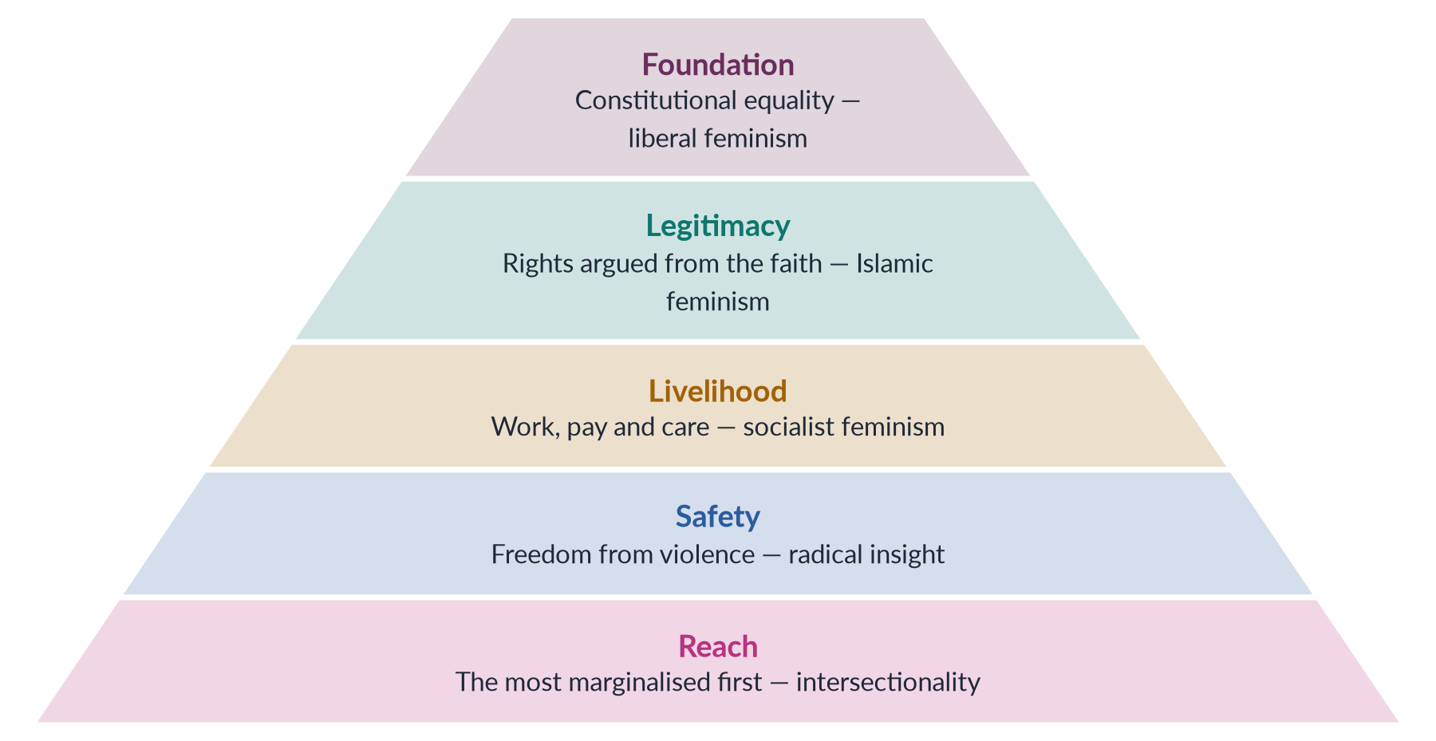
Figure 4 · A layered feminism for Pakistan, from the foundation up.

9. The less suitable schools

i) Pure radical and Marxist feminism
Separatist radical feminism provokes backlash and is easily painted as foreign. Marxist feminism waits for a revolution that is not coming; its insight on unpaid work survives better through socialist policy.

ii) Postmodern and psychoanalytic feminism
Postmodern feminism is too abstract for policy, but it warns against speaking of "the Pakistani woman" as one person. Psychoanalytic feminism offers no quick policy, but its call for shared parenting matters for the long term.

10. Conclusion
The answer to "which type(s)?" is all the useful parts of several: liberal in law, Islamic in cultural justification, socialist in economics, radical in its refusal to tolerate violence, inclusive of men, and intersectional in whom it reaches first. This is not a compromise; it is how Pakistan's own successful reforms were won — from the Muslim Family Laws Ordinance (1961) to the honour-killing law of 2016, each combined constitutional rights, Islamic argument and women's activism.

Why this answer scores
- It answers "type(s)" literally — several schools, each matched to one of the three dimensions named in the question.
- A table of Pakistani data and a pyramid figure make the argument visible.
- Each school has what it offers → Pakistani evidence → its limit, so the answer is balanced.
- The less suitable schools are dealt with fairly, not ignored.
- The conclusion ties the model to Pakistan's own reform history, answering the "Western agenda" objection.

Answer 3 · Short Note: Postmodern Feminism (CSS 2019)
AT A GLANCE · CSS 2019 · Q8(B) · 10 MARKS
Write short notes on any TWO: Postmodern Feminism

The answer map
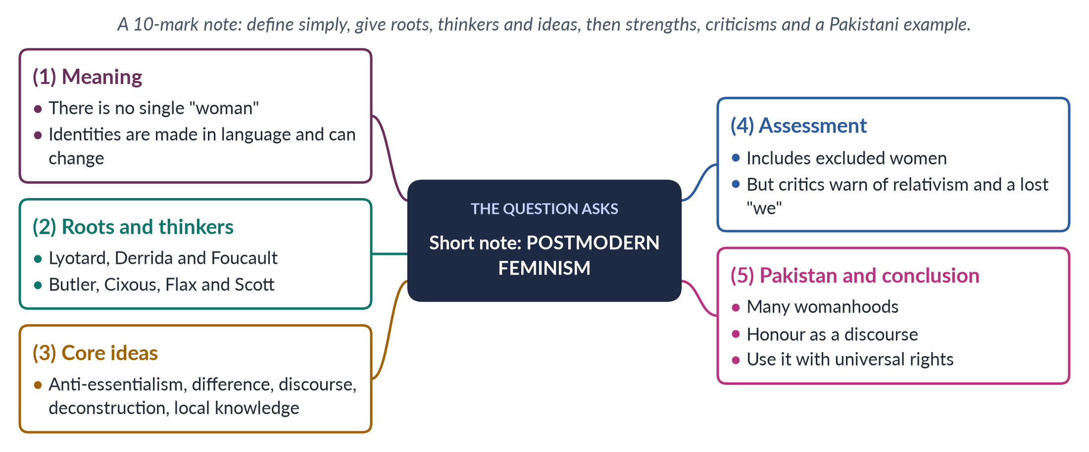
Figure 5 · The answer map for the short note: every branch is one headed point.

Decoding the question
A short note of 10 marks: about 550–650 words, four or five headed points, a definition, thinkers with dates, core ideas, a balanced assessment and one Pakistani example. The examiner rewards a note that makes a hard theory simple.

The model answer

1. Meaning

i) Definition
Postmodern feminism holds that there is no single, universal "woman" and no single cause of women's oppression. Gender identities are constructed in language and discourse, are multiple, and can change.

ii) Two key words
Post-structural feminism stresses "the contingent and discursive nature of identities". Contingent means not fixed — it could be otherwise. Discursive means made by discourse — the ways a society talks and thinks about something, and who is allowed to speak.

iii) In simple words
"Woman" meant something different in 1850 London, 1950 Lahore and 2026 Karachi. Postmodern feminists say this is because the meaning of woman is made by each society's language, laws and stories — so it can be remade.

2. Roots and thinkers

i) Postmodern roots
Jean-François Lyotard (The Postmodern Condition, 1979) defined the postmodern as "incredulity toward metanarratives" — disbelief in grand stories that explain everything. Jacques Derrida (1967) developed deconstruction, which exposes ranked opposites such as man/woman. Michel Foucault (1975–76) joined power and knowledge: discourses define what is "normal".

ii) Feminist thinkers
Judith Butler (Gender Trouble, 1990) argued that gender is performative — created by repeated acts. Hélène Cixous ("The Laugh of the Medusa", 1975) called for écriture féminine, women's writing from their own bodies and experience. Jane Flax (1987) and Joan Scott (1986, 1988) brought postmodern ideas into feminist theory.

3. Core ideas
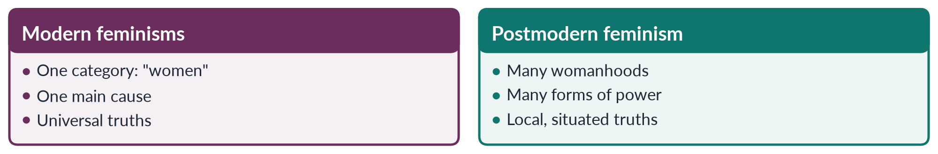
Figure 6 · Modern feminisms and postmodern feminism.

i) Anti-essentialism and difference
Women share no fixed essence; they differ by class, race, religion, sexuality and nation, and feminism must recognise this.

ii) Language and literature
Language makes reality, so changing words and stories changes gender. This is why gender equality constructed through literature is linked to postmodern feminism.

iii) Suspicion of grand theories
Neither liberal, Marxist nor radical theory can explain all women's oppression. Postmodern feminists prefer local and personal knowledge — the stories of particular women in particular places.

iv) Deconstruction of binaries
Western thought ranks man over woman, reason over emotion, culture over nature. Postmodern feminists expose these ranked pairs as made, not natural, and so open them to change.

4. Assessment

i) Strengths
It opened feminism to women excluded by earlier theories — women of colour, Muslim women, poor women. It shows how media, textbooks and language shape gender. And if identities are not fixed, change is always possible.

ii) Criticisms
Seyla Benhabib (1995) warned that the "death of the subject" leaves no one to act. If there is no "woman", on whose behalf does feminism speak? Martha Nussbaum ("The Professor of Parody", 1999) attacked its jargon and distance from real struggles. Relativism could excuse harmful customs.

iii) The reply
Gayatri Spivak's strategic essentialism allows temporary unity around an identity to win political goals — women can campaign together as "women" for a law, while knowing that womanhood takes many forms.

5. Pakistan and conclusion

i) Pakistan
There is no single "Pakistani woman": a Karachi banker, a Thari peasant and a khawaja sira live very different lives. The idea of ghairat (honour) is a discourse that treats a woman's body as family property; deconstructing it is a first step against honour crimes. Poets such as Kishwar Naheed ("We Sinful Women") rewrote the language of female obedience.

ii) Conclusion
Postmodern feminism is best used as a lens, not a programme: it teaches feminists to ask "which women?", while universal human rights remain the floor.

Why this answer scores
- A hard theory is defined in plain words, and the MCQ phrase "contingent and discursive" is explained.
- Thinkers with dates and a small compare figure fit a 10-mark note.
- Both strengths and criticisms appear, with Spivak's reply.
- A Pakistani example makes the theory concrete.

Answer 4 · The Development and Stance of Marxist/Socialist Feminism (CSS 2021)
AT A GLANCE · CSS 2021 · Q4 · 20 MARKS
Marxist feminism is a philosophical variant of feminism that incorporates and extends Marxist theory and analyzes the ways in which women are exploited through capitalism and the individual ownership of private property. Discuss the development of Marxist/Socialist feminism and the philosophical stance it holds on gender issues and exploitation.

The answer map
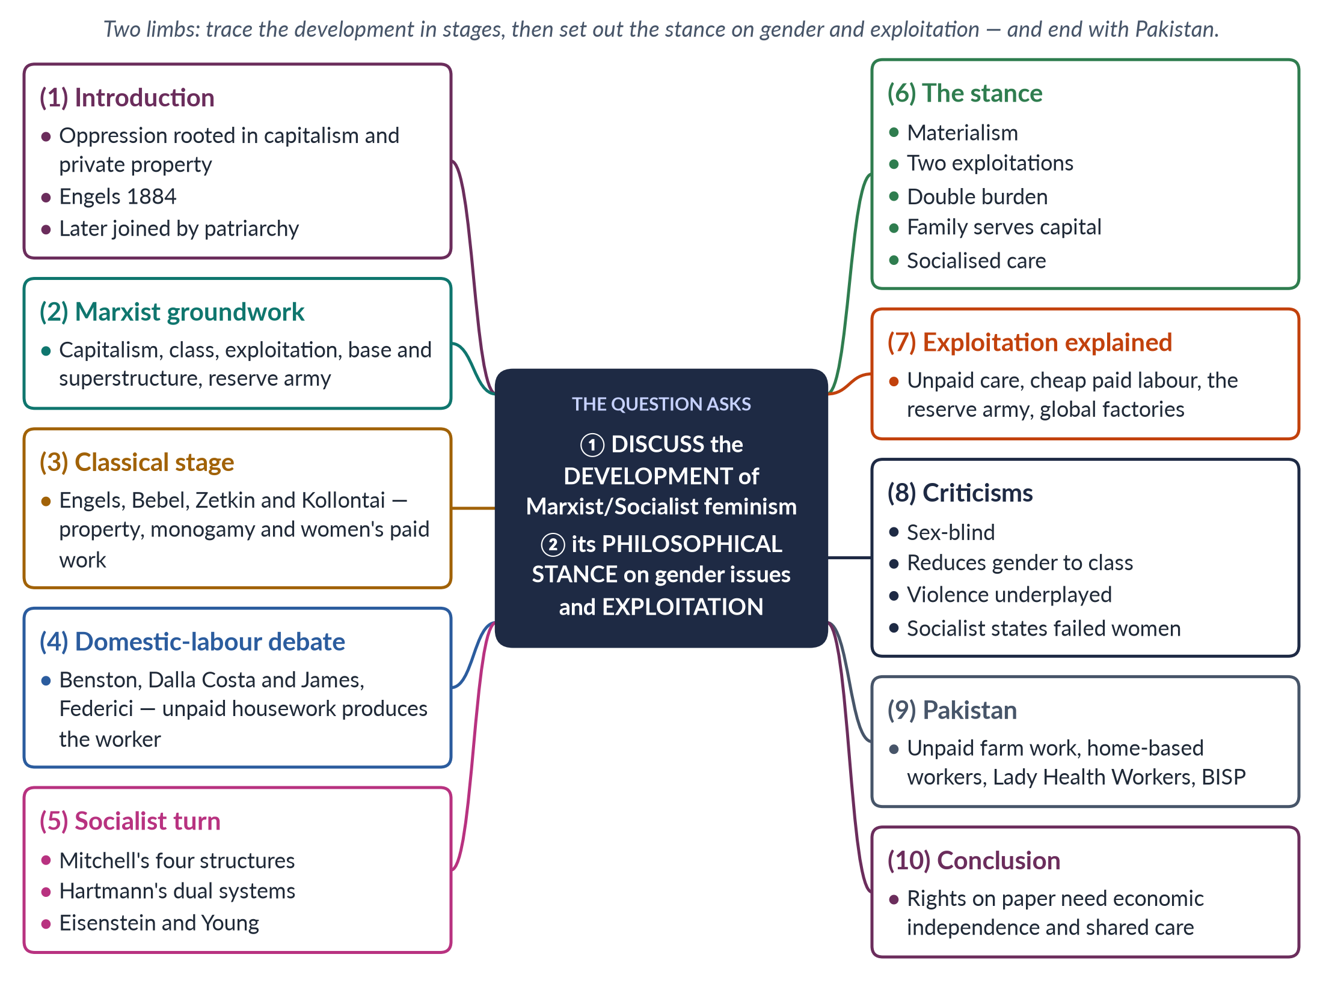
Figure 7 · The answer map: every branch is one numbered heading of the model answer below.

Decoding the question
The question gives its own definition — use it in your introduction. It has two limbs. "Discuss the development" asks for stages over time, with thinkers and dates. "The philosophical stance … on gender issues and exploitation" asks for the school's core beliefs — why women are oppressed and how they are exploited. The slash in "Marxist/Socialist" invites you to show how socialist feminism grew out of Marxist feminism and how they differ.

The model answer

1. Introduction

i) Definition
Marxist feminism holds that women are exploited through capitalism and private property. Socialist feminism accepts this but adds a second system, patriarchy, which works together with capitalism.

ii) Origin
The school began with Friedrich Engels's The Origin of the Family, Private Property and the State (1884) and grew through the domestic-labour debate of the 1970s.

iii) The argument
Its lasting contribution is to show that women's disadvantage is material — rooted in who does paid and unpaid work and who owns property. Legal equality means little without economic independence.

2. The Marxist groundwork

i) Five terms
Capitalism: a few own the means of production; most sell their labour. Class: owners (bourgeoisie) and workers (proletariat). Exploitation: workers produce more value than they are paid; the owner keeps the profit. Base and superstructure: the economy shapes the family, law and ideas. Reserve army of labour: workers hired in booms and dropped in slumps.

ii) Why these matter
Marxist feminists applied these terms to women — asking what work women do, who profits from it, and why it is unpaid.

3. Stage one — classical Marxist feminism (1879–1920s)

i) Engels
Engels argued that when men began to own private property, they wanted to pass it to their own sons. To be certain of paternity, they imposed monogamy on women and took control of the household — "the world historical defeat of the female sex". Women will be free when private property ends and they enter paid production as equals.

ii) Bebel, Zetkin and Kollontai
August Bebel (Woman and Socialism, 1879) linked women's and workers' struggles. Clara Zetkin proposed International Women's Day at Copenhagen in 1910. Alexandra Kollontai pushed for communal kitchens and childcare in the Soviet Union after 1917.

4. Stage two — the domestic-labour debate (1969–1975)

i) Housework as production
Margaret Benston (1969) argued that housework is real production — meals, clean clothes, cared-for children — but, being unpaid, is not counted as work.

ii) Producing the worker
Mariarosa Dalla Costa and Selma James (1972) argued that housework produces the most important commodity of all: the worker himself, fed and rested each morning. This launched the Wages for Housework campaign (1972). Silvia Federici (1975) wrote: "They say it is love. We say it is unwaged work."

iii) Social reproduction
This work of keeping people alive and able to work is called social reproduction. Capitalism depends on it but does not pay for it.
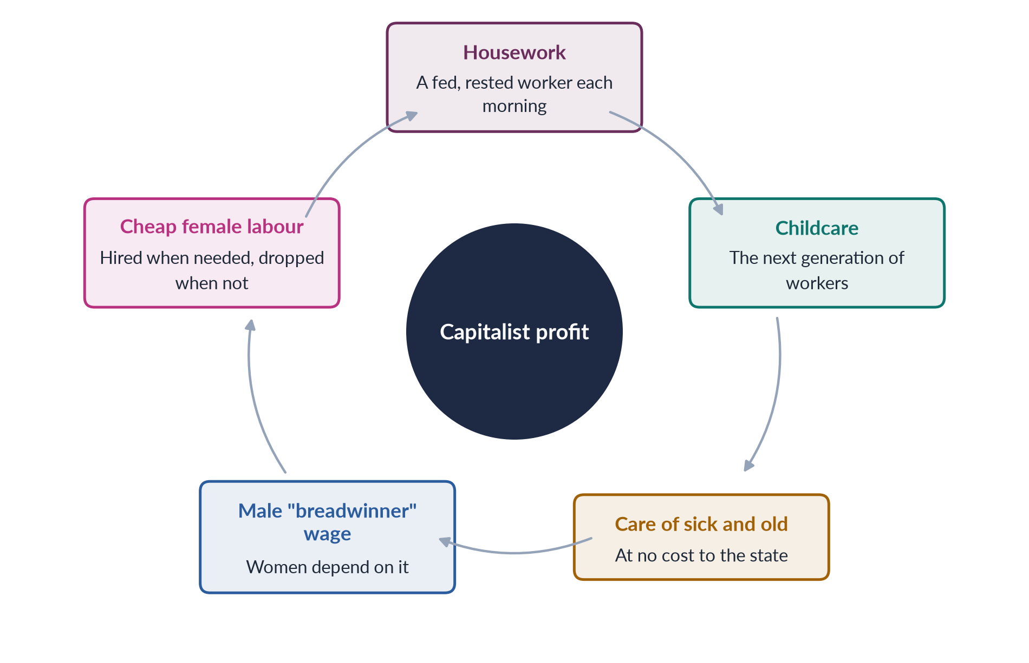
Figure 8 · How women's unpaid work keeps capitalism running.

5. Stage three — the socialist turn (1966–1990)

i) Mitchell
Juliet Mitchell ("Women: The Longest Revolution", 1966; Woman's Estate, 1971) said women's position rests on four structures: production, reproduction, sexuality and the socialisation of children. Changing the economy alone will not free women.

ii) Hartmann
Heidi Hartmann ("The Unhappy Marriage of Marxism and Feminism", 1979) called Marxism "sex-blind": it explains why workers are exploited, but not why men dominate women in every class. Her dual-systems theory treats capitalism and patriarchy as two linked systems. Her example: male trade unions won a family wage for men, pushing women back into the home.

iii) Eisenstein, Young, Mies and Walby
Zillah Eisenstein (1979) coined "capitalist patriarchy". Iris Marion Young (1980) argued for one unified system. Maria Mies (1986) described the "housewifisation" of women's work worldwide. Sylvia Walby (1990) identified six structures of patriarchy.

6. The philosophical stance

i) Materialism
Women's position is explained by material conditions — work, property, money — not by nature.

ii) The family serves capital
The family produces and maintains workers cheaply and passes on property.

iii) The double burden
Women who take paid work still do the housework — the "second shift" (Arlie Hochschild, 1989).

iv) Two exploitations, one system
Women are exploited as unpaid workers at home and as low-paid workers outside it. The two are linked: because housework is assumed to be women's duty, employers treat women's wages as "extra" and pay them less.

v) The remedy
Liberation needs economic independence and socialised care: public childcare, paid leave, equal pay. Marxists add the end of capitalism; socialists add the end of male privilege at home and work.

7. Exploitation explained
Table 3 · The four forms of exploitation in Marxist/socialist feminism.
Form | Meaning and example
Unpaid domestic labour | Cooking, cleaning and care that keep workers alive, done free
Cheap paid labour | "Women's jobs" — stitching, cleaning, nursing — paid less
Reserve army | Women hired in booms or wars and pushed out in slumps
Global assembly line | Young women in export factories of the global South, paid little

8. Criticisms

i) Sex-blind
Marxism cannot explain male power within the working class (Hartmann).

ii) Too economic
It underplays violence, sexuality and culture — the concerns of radical feminism.

iii) The socialist record
Women in the Soviet Union entered paid work in large numbers but still carried a double burden at home.

iv) Wages for housework
Critics feared that paying for housework would fix women in the home rather than share the work with men.

v) The reply
Socialist feminists accept much of this criticism — which is precisely why they added patriarchy to capitalism. Today's care-economy debates, and SDG target 5.4 on recognising unpaid care, show the school's continuing influence.

9. Pakistan

i) Unpaid and cheap work
Female labour-force participation is only 24.4% (LFS 2024–25). Most employed women work in agriculture, much as unpaid family helpers. Millions of home-based workers earn piece rates; Sindh passed the first Home-Based Workers Act in 2018.

ii) Organised struggle
The Lady Health Workers (programme from 1994) fought for regular jobs, winning a Supreme Court order in 2012. Rural women of the Sindhiani Tehreek (from 1982) and the Okara tenants' movement (from 2000) joined land and class struggles.

iii) Policy
The Benazir Income Support Programme (2008) pays cash to women — a small recognition of their role in family survival.

10. Conclusion
Marxist/socialist feminism developed from Engels's theory of property, through the domestic-labour debate, to the dual-systems theory of Hartmann. Its stance is that women are exploited twice — as unpaid carers and as cheap workers — by capitalism and patriarchy together. Its critics are right that economics is not everything. But for Pakistan, where most women's work is unpaid or underpaid, its lesson is essential: rights on paper need economic independence and shared care to become rights in life.

Why this answer scores
- The question's own definition opens the answer.
- Development is shown in three dated stages, and stance under its own heading — both limbs answered.
- A cycle figure and a table make the argument of exploitation visible.
- Criticisms are fair, and the Pakistan section uses current data and real movements.

Answer 5 · Gender Oppression in Psychoanalytic Feminism (CSS 2021)
AT A GLANCE · CSS 2021 · Q5 · 20 MARKS
Psychoanalytic feminism is a theory of oppression which asserts that men have an inherent psychological need to subjugate women. Give a detailed analysis of gender oppression and women's subordination promulgated by Psychoanalytic Feminism.

The answer map
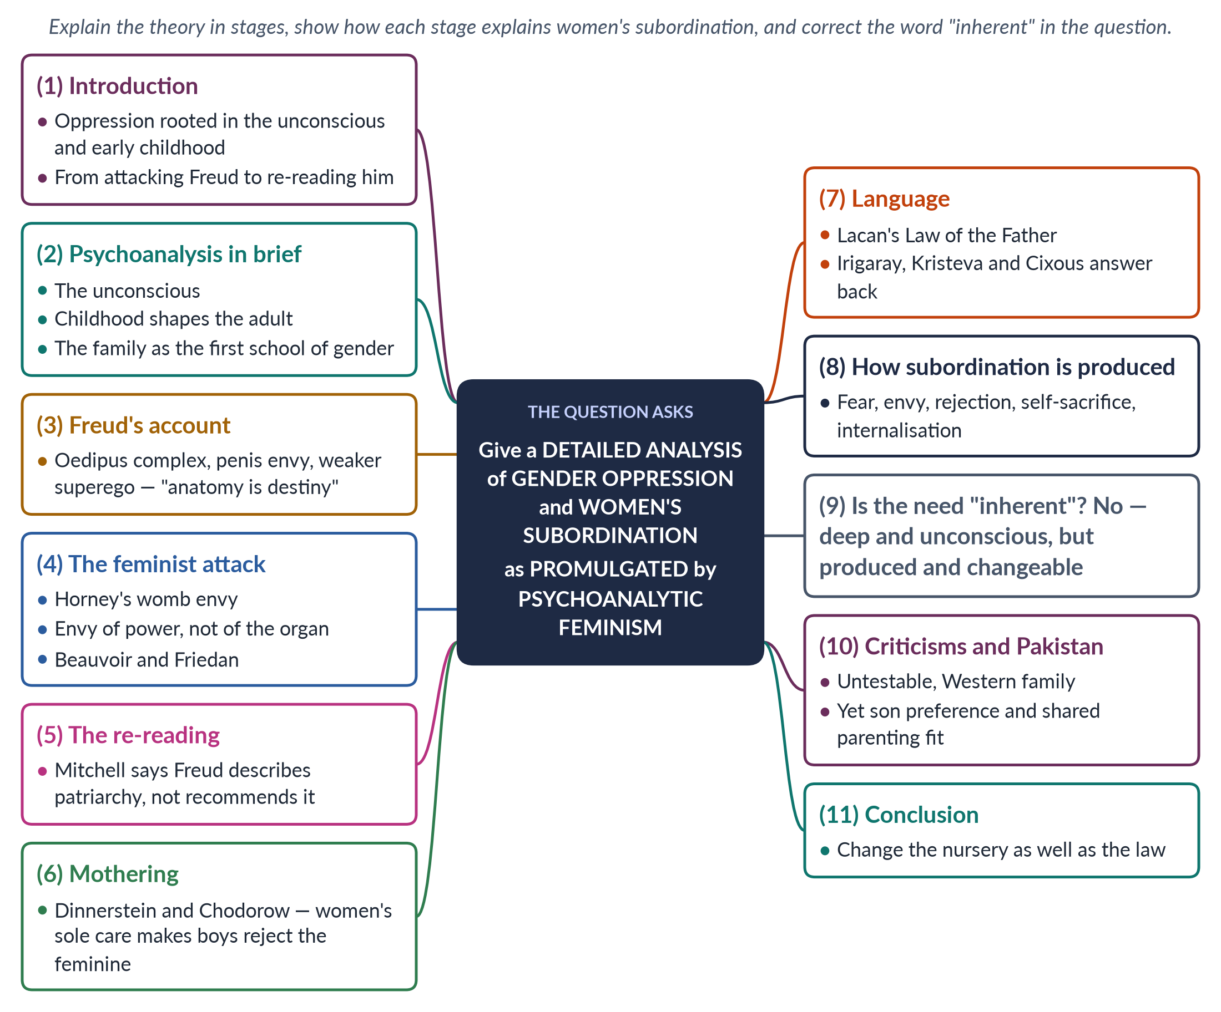
Figure 9 · The answer map: every branch is one numbered heading of the model answer below.

Decoding the question
The question gives a definition — that men have "an inherent psychological need to subjugate women" — and asks for "a detailed analysis of gender oppression and women's subordination" as this school explains it. "Detailed analysis" means breaking the theory into its parts and showing how each part explains subordination. A top answer also tests the definition: most psychoanalytic feminists say the need is produced by childrearing, not inherent.

The model answer

1. Introduction

i) Definition
Psychoanalytic feminism locates the roots of women's oppression in the psyche — in the unconscious mind and in what happens to boys and girls in early childhood within the family.

ii) Background
It began by attacking Sigmund Freud, whose theory seemed to make women's inferiority natural, and ended by re-reading him to explain why patriarchy is so deep and so hard to change.

iii) The argument
The school shows that male dominance and female submission are built into personality before a child can reason. But it also shows that they are produced, not inherent — and so can be changed by changing how children are raised.

2. Psychoanalysis in brief

i) The unconscious
Much of what we feel and want is hidden from us; it shows itself in dreams, slips and symptoms.

ii) Childhood and the family
Personality — including the sense of being male or female — is formed in the first years of life, mainly in relations with parents. The family is the first school of gender.

3. Freud's account of femininity

i) The Oedipus complex
Around the age of three to five, the boy desires his mother, fears castration by his father, gives up the mother and identifies with the father, building a strong superego (conscience).

ii) Penis envy
The girl discovers she lacks a penis, feels inferior (penis envy), turns from her mother to her father, and later wishes for a baby as a substitute. Freud concluded (1925) that women have a weaker superego and are more passive.

iii) "Anatomy is destiny"
Freud's phrase (1924) sums up the claim: women's bodies fix their psychological fate. Feminists saw at once that this made male superiority look natural.

4. The feminist attack on Freud

i) Karen Horney
In "The Flight from Womanhood" (1926), Karen Horney argued that girls envy men's social power and freedom, not the organ. She reversed Freud with womb envy: men envy women's power to create life and compensate through achievement and domination. This is the nearest the school comes to the question's claim of a male "need to subjugate women".

ii) Beauvoir, Friedan and Millett
Simone de Beauvoir (1949) rejected biology as destiny. Betty Friedan (1963) and Kate Millett (1970) blamed popular Freudianism for keeping women at home.

5. The re-reading of Freud
Juliet Mitchell (Psychoanalysis and Feminism, 1974) argued that psychoanalysis is "not a recommendation for a patriarchal society, but an analysis of one". Freud described how patriarchal culture enters every child's mind. Understanding that process explains why patriarchy survives even when laws change.

6. Mothering and the making of men

i) Dinnerstein
Dorothy Dinnerstein (The Mermaid and the Minotaur, 1976) argued that because women alone care for infants, every child's first experience of total dependence — love, rage and fear — is with a woman. Adults of both sexes carry an unconscious fear of female power, which they manage by keeping women under control.

ii) Chodorow
Nancy Chodorow (The Reproduction of Mothering, 1978) argued that a girl grows up in continuity with her mother and develops a relational self — she wants to care. A boy must become "not-mother"; he builds his masculinity by separation, denies feelings and devalues the feminine. So mothering reproduces the gender order in every generation.
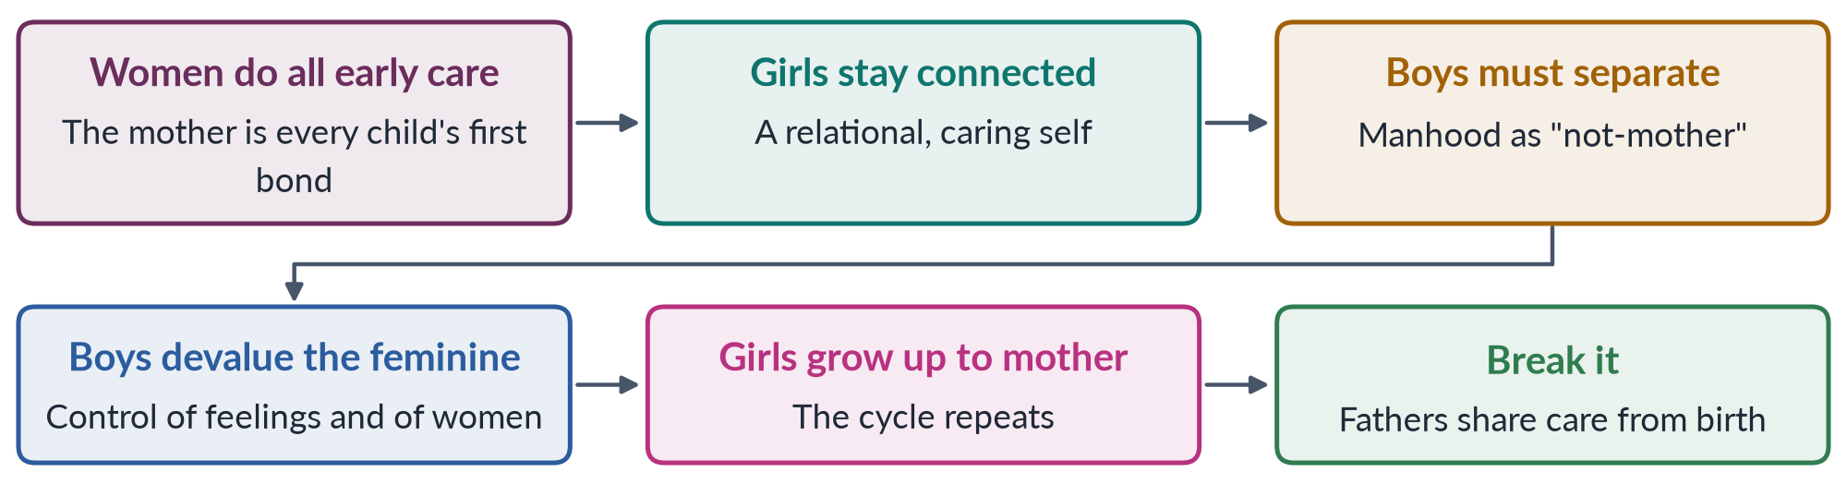
Figure 10 · Chodorow's cycle: how women's sole mothering reproduces male dominance.

iii) Gilligan
Carol Gilligan (In a Different Voice, 1982) showed that women's ethic of care had been ranked below men's ethic of justice — subordination built into psychology itself.

7. Language and the symbolic order

i) Lacan
Jacques Lacan argued that the child enters language and culture — the symbolic order — under the "Law of the Father". The phallus is the symbol of power and meaning, so culture speaks from a male position, and woman appears only as "lack".

ii) The French feminists
Luce Irigaray (1974, 1977) showed woman reduced to a mirror of man. Julia Kristeva (1974) found a maternal "semiotic" that disturbs the male order. Hélène Cixous (1975) called for écriture féminine — women writing from their own bodies.

8. How subordination is produced — the analysis
Table 4 · Psychoanalytic feminism's explanation of women's subordination.
Mechanism | How it subordinates women | Thinker
Envy | Men envy women's creative power and compensate by domination | Horney
Fear | Fear of the all-powerful mother leads to control of women | Dinnerstein
Rejection | Boys become men by rejecting the feminine | Chodorow
Self-sacrifice | Girls learn to define themselves by caring for others | Chodorow, Gilligan
Male-centred culture | Language and law speak from a male position | Lacan, Irigaray
Internalisation | Women absorb and even defend their own subordination | Mitchell

9. Is the need really "inherent"?

i) Freud's view
Freud treated sex differences as largely innate.

ii) The feminist view
Most psychoanalytic feminists disagree. For Horney the envy is of social power; for Dinnerstein and Chodorow domination is produced by who raises children. The need is deep and unconscious, but not natural or permanent.

iii) The remedy
Shared parenting: if fathers cared for infants from birth, boys would not need to reject the feminine to become men, and adults would not fear female power.

10. Criticisms and the Pakistan angle

i) Criticisms
The theory is untestable; it assumes a Western nuclear family; it ignores law, money and violence; and it risks blaming mothers.

ii) Pakistan
Yet its insights fit Pakistani family life. Son preference teaches girls early that they are valued less. Boys are moved into male spaces and told "men don't cry" — Chodorow's separation. A mother's security often depends on her son, and her power as mother-in-law — Deniz Kandiyoti's "patriarchal bargain" (1988) — can lead women to defend the system. Growing numbers of urban fathers now share childcare; the theory suggests this matters more than it seems.

11. Conclusion
Psychoanalytic feminism explains what laws alone cannot: why male dominance feels natural and why many women accept it. It traces subordination to envy, fear, rejection of the feminine and a male-centred culture, all learnt in the nursery. The question's word "inherent" should be corrected: the need to dominate is made, not born. The school's lesson is that to change society, we must change the nursery as well as the law.

Why this answer scores
- The theory is analysed in clear stages — Freud, attack, re-reading, mothering, language.
- A table turns the "detailed analysis" into six named mechanisms with thinkers.
- A flow figure shows Chodorow's cycle at a glance.
- The answer tests the question's own definition — examiners reward this.
- Criticisms and a Pakistan angle complete a balanced answer.

Answer 6 · Two Western Schools of Feminist Thought: Liberal and Radical Feminism (CSS 2022)
AT A GLANCE · CSS 2022 · Q3 · 20 MARKS
Describe any two Western schools of thought about feminism in detail.

The answer map
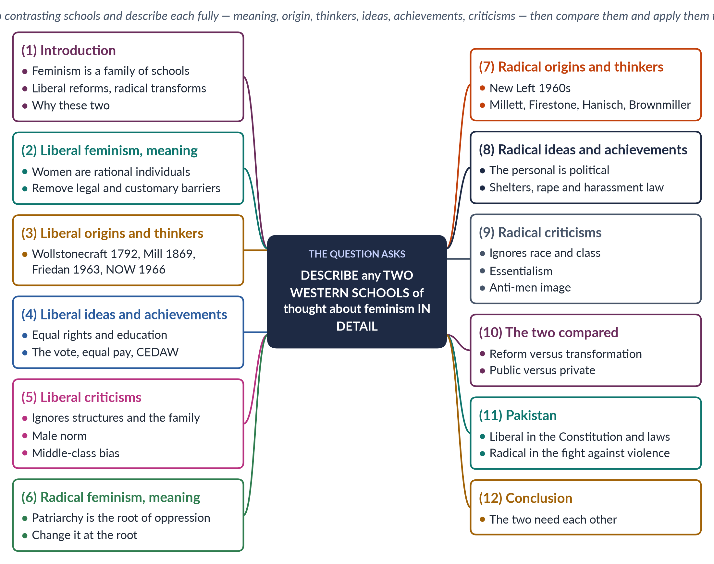
Figure 11 · The answer map: every branch is one numbered heading of the model answer below.

Decoding the question
"Describe … in detail" asks for full, organised description — not a list of names. "Any two" lets you choose: pick two schools that contrast well and that you know deeply. Liberal and radical feminism are the best pair: the first is the most influential in law, the second the most influential on violence against women. Describe each under the same sub-headings, then add a short comparison and a Pakistan angle — that is what "in detail" earns.

The model answer

1. Introduction

i) Definition
Feminism is the belief in equal rights and chances for women and men, with action to achieve it. Western feminist thought has produced several schools — liberal, radical, Marxist, socialist, psychoanalytic and postmodern — each explaining women's disadvantage differently.

ii) The two schools chosen
This answer describes liberal feminism, which seeks reform within the existing system, and radical feminism, which seeks transformation at the root. Together they show the range of Western feminist thought.

2. Liberal feminism — meaning

i) Definition
Liberal feminism holds that women are as capable of reason as men, and that their disadvantage comes from unequal laws, customs and opportunities. The remedy is equal rights, equal education and equal access to work and public life.

ii) Its roots
It grows from Enlightenment liberalism: every individual has reason and natural rights. Liberal feminists ask why these rights should stop at women.

iii) In simple words
If a girl is as able as her brother, she should have the same school, the same vote, the same chance at a job and the same protection of law. Remove the barriers, and she will rise on merit.

3. Liberal feminism — origins and thinkers

i) First wave
Mary Wollstonecraft (A Vindication of the Rights of Woman, 1792) answered Rousseau: women seem weak because they are denied a rational education. At Seneca Falls (1848) the Declaration of Sentiments declared "all men and women are created equal". John Stuart Mill (The Subjection of Women, 1869), with Harriet Taylor Mill, called the legal subordination of women wrong in itself and a barrier to progress.

ii) Second wave
Betty Friedan (The Feminine Mystique, 1963) described "the problem that has no name" — the emptiness of educated housewives — and co-founded the National Organization for Women (1966).

iii) Later
Susan Moller Okin (1989) argued that the family must be just; Martha Nussbaum (2000) applied the capabilities approach to women.

4. Liberal feminism — ideas and achievements

i) Core ideas
Individual rights, equality of opportunity, education, reform through law and focus on the public sphere.

ii) Achievements
The vote (New Zealand 1893, USA 1920, Britain 1928), access to universities and professions, the US Equal Pay Act (1963), and the UN CEDAW (1979), which Pakistan ratified in 1996. US law also banned sex discrimination in employment (Title VII, 1964).

iii) Methods
Liberal feminists work through lobbying, lawsuits, legislation and elections — the ordinary tools of a democracy. This makes the school practical and widely acceptable.

5. Liberal feminism — criticisms

i) Structures ignored
Equal laws do not produce equal results while women do most unpaid care.

ii) The private sphere
It keeps the state out of the family, where much inequality lives.

iii) A male norm and a class bias
It asks women to become like men in a system built around men's lives; bell hooks said Friedan spoke only for educated white housewives, while poor and Black women had always worked.

iv) Individualism
It focuses on individual merit and choice, and underplays the group disadvantage that holds whole classes of women back.

6. Radical feminism — meaning

i) Definition
"Radical" comes from Latin radix, root. Radical feminism holds that patriarchy — male power over women — is the oldest and deepest oppression, found in every area of life, above all the family, sexuality, the body and violence.

ii) Its remedy
Reform is not enough; society and culture must be transformed at the root.

iii) In simple words
A new law against harassment helps, but the radical feminist asks why men harass at all. The answer — a culture that treats women's bodies as men's to use — must itself be changed.

7. Radical feminism — origins and thinkers

i) Origin
It arose in the USA in the late 1960s, when women in the civil-rights and anti-war "New Left" found themselves sidelined by male comrades. Groups such as New York Radical Women (1967) and Redstockings (1969) followed.

ii) Thinkers
Kate Millett (Sexual Politics, 1970) showed sex relations to be power relations and made "patriarchy" the key concept. Shulamith Firestone (The Dialectic of Sex, 1970) traced oppression to reproduction and called women a "sex class". Carol Hanisch gave the slogan "The Personal Is Political" (1970). Susan Brownmiller (1975) showed rape as a tool of fear. Adrienne Rich (1976, 1980) separated motherhood as an experience from motherhood as an institution controlled by men.

iii) Two branches
Radical-libertarian feminists (Firestone) wanted to free people from rigid gender; radical-cultural feminists (Mary Daly) wanted to revalue women's qualities of care and peace.

8. Radical feminism — ideas and achievements

i) Core ideas
Patriarchy, sexual politics, the personal is political, consciousness-raising (women sharing experiences to see their political cause) and bodily autonomy.

ii) Achievements
Rape crisis centres and women's shelters (London, 1971); domestic violence redefined as a public crime; sexual harassment recognised as discrimination (Catharine MacKinnon, 1979).

9. Radical feminism — criticisms

i) One "woman"
It treated women as one group, ignoring race and class (hooks, Audre Lorde).

ii) Essentialism and image
Firestone's focus on biology risks essentialism; separatist writing gave it an anti-men image; the 1980s "sex wars" divided the movement.

10. The two compared
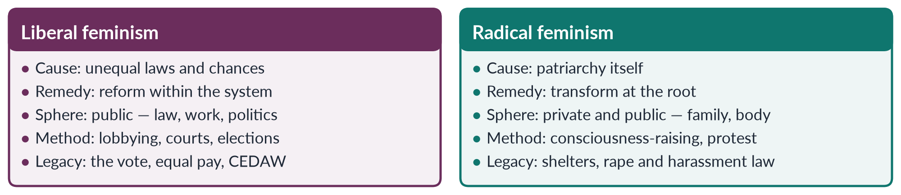
Figure 12 · Liberal and radical feminism side by side.

i) Where they agree
Both agree that women's disadvantage is made by society, not by nature, and both have changed the law.

ii) Where they differ
They disagree on its depth and therefore on the cure: liberals see barriers to be removed; radicals see a system of power to be dismantled. Liberals speak to parliaments; radicals speak first to women themselves.

11. The Pakistan angle

i) Liberal
Pakistan's Constitution is liberal in spirit — Articles 25, 27 and 34 — and laws on harassment (2010) and child marriage (2025) follow the liberal route.

ii) Radical
The Women's Action Forum (1981) against the Hudood Ordinances, the laws on honour killing (2016) and rape (2021), and the Aurat March demand for bodily autonomy reflect radical insight.

12. Conclusion
Liberal feminism built women's legal equality; radical feminism exposed the power and violence that laws alone could not reach. The first gives rights, the second shows why rights are not enough. In Pakistan, as elsewhere, the two need each other: liberal law provides the tools, radical analysis shows where to use them.

Why this answer scores
- The choice of schools is explained — the examiner sees a thinking candidate.
- Both schools are described under the same sub-headings: meaning, origin and thinkers, ideas and achievements, criticisms — true "detail".
- Thinkers, books and dates are exact.
- A compare figure and a Pakistan section lift the answer above description.

Answer 7 · Short Note: Radical Feminism (CSS 2024)
AT A GLANCE · CSS 2024 · Q8(B) · 10 MARKS
Write short notes on: Radical Feminism

The answer map
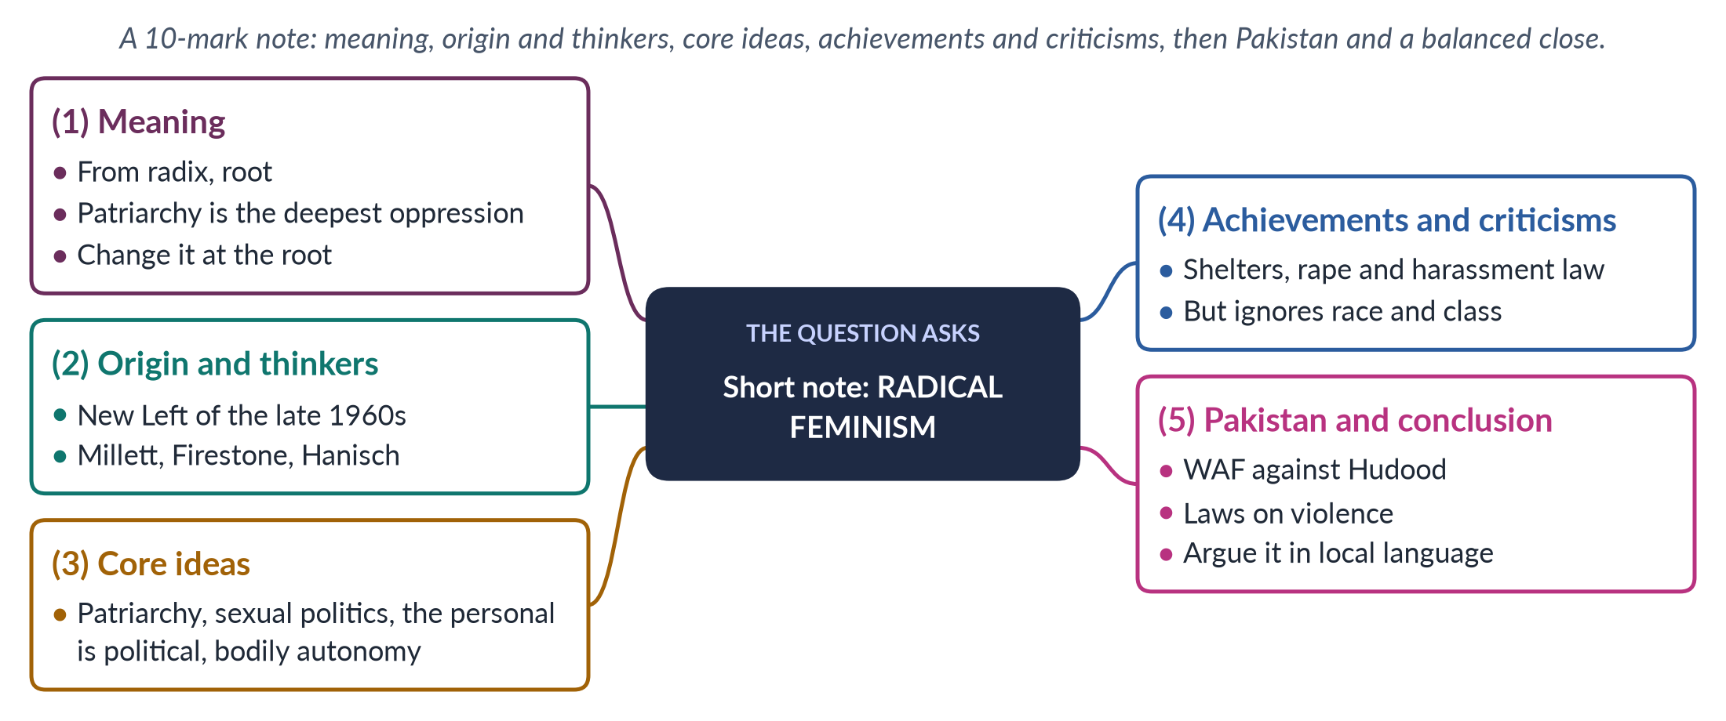
Figure 13 · The answer map for the short note: every branch is one headed point.

Decoding the question
A short note of 10 marks: about 550–650 words under four or five headings — definition, origin and thinkers with dates, core ideas, achievements, criticisms, a Pakistani example and a balanced close. A small figure earns extra credit.

The model answer

1. Meaning

i) Definition
"Radical" comes from the Latin radix, meaning root. Radical feminism holds that patriarchy — the system of male power over women — is the oldest and deepest form of oppression, present in every society and every area of life.

ii) The remedy
Because patriarchy runs through the family, sexuality, the body and culture, legal reform is not enough. Society must be transformed at the root. A past MCQ put it simply: replacing patriarchy is a radical idea.

2. Origin and thinkers

i) Origin
Radical feminism arose in the USA in the late 1960s. Women active in the civil-rights and anti-war "New Left" found that male comrades who preached equality expected them to make coffee and stay silent. They formed groups such as New York Radical Women (1967) and Redstockings (1969).

ii) Thinkers
- Kate Millett (Sexual Politics, 1970): relations between the sexes are power relations; she made "patriarchy" the key concept.
- Shulamith Firestone (The Dialectic of Sex, 1970): oppression began in reproduction; women are a "sex class".
- Carol Hanisch ("The Personal Is Political", 1970): women's private problems are political.
- Susan Brownmiller (Against Our Will, 1975): rape keeps all women in fear.

3. Core ideas
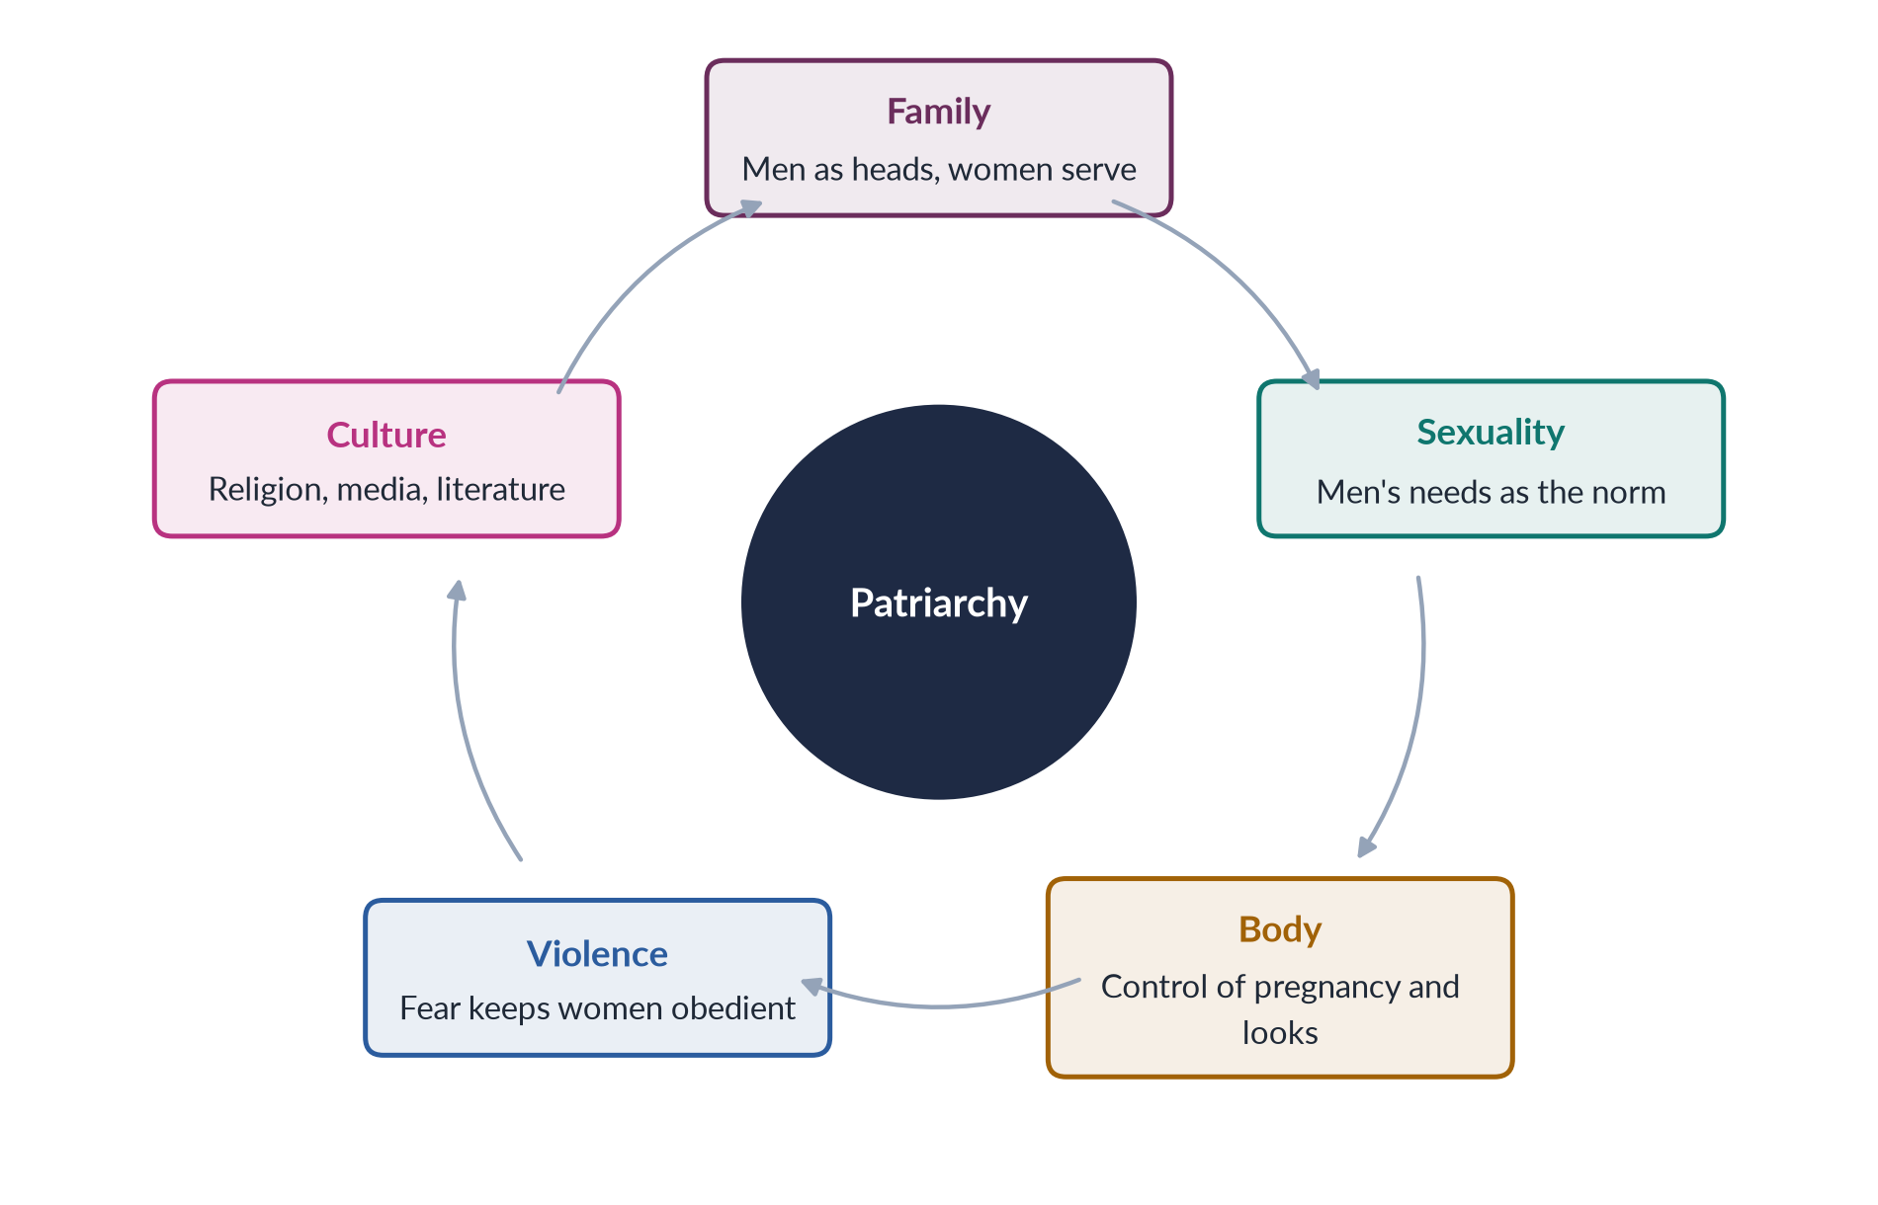
Figure 14 · Radical feminism: patriarchy at work in every area of life.

i) Patriarchy and sexual politics
Male power is not a side effect of capitalism or law; it is a system of its own.

ii) The personal is political
Housework, marriage and sex are shaped by power. Women discovered this through consciousness-raising groups, where private complaints — an exhausting double day, a controlling husband — turned out to be shared by all, with a common cause.

iii) Bodily autonomy
Women must control their own bodies — free from violence, forced marriage and control of reproduction. Adrienne Rich (1976) separated motherhood as a woman's experience from motherhood as an institution run by men.

iv) Two branches
Radical-libertarians (Firestone) wanted to escape rigid gender; radical-cultural feminists (Mary Daly) wanted to celebrate women's values.

4. Achievements and criticisms

i) Achievements
Radical feminism made violence against women a public issue. It created rape crisis centres and shelters (the first modern shelter, London, 1971), redefined domestic violence as a crime, and — through Catharine MacKinnon (1979) — made sexual harassment a form of discrimination.

ii) Criticisms
It treated all women as one group, ignoring race and class (bell hooks). Firestone's focus on biology risks essentialism. Separatist writing gave feminism an anti-men image, and its language on sexuality provokes backlash in conservative societies. Historians add that patriarchy takes different forms in different times, so it cannot be one unchanging system.

5. Pakistan and conclusion

i) Pakistan
The Women's Action Forum (1981) fought the Hudood Ordinances (1979), which exposed rape victims to adultery charges. Later laws on acid attacks (2011), honour killing (2016) and rape (2021) reflect the radical insight that violence controls women. The Aurat March slogan Mera Jism Meri Marzi echoed the demand for bodily autonomy — and showed how slogans can provoke controversy.

ii) Conclusion
Radical feminism's analysis of power and violence has saved lives and changed laws worldwide. Its style can alienate potential allies, and its claim that all women share one oppression needs the correction of intersectional thinking. In Pakistan its demands succeed best when argued in the language of the Constitution and of Islam's protection of human dignity.

Why this answer scores
- Definition, origin, thinkers with dates, ideas, achievements, criticisms — every part a 10-mark note needs.
- A small cycle figure shows patriarchy at a glance.
- The Pakistani example is precise and balanced.

Answer 8 · The Intersectionality of Gender with Other Social Identities (CSS 2025)
AT A GLANCE · CSS 2025 · Q6 · 20 MARKS
Give a detailed analysis of the intersectionality of gender with other social identities.

The answer map
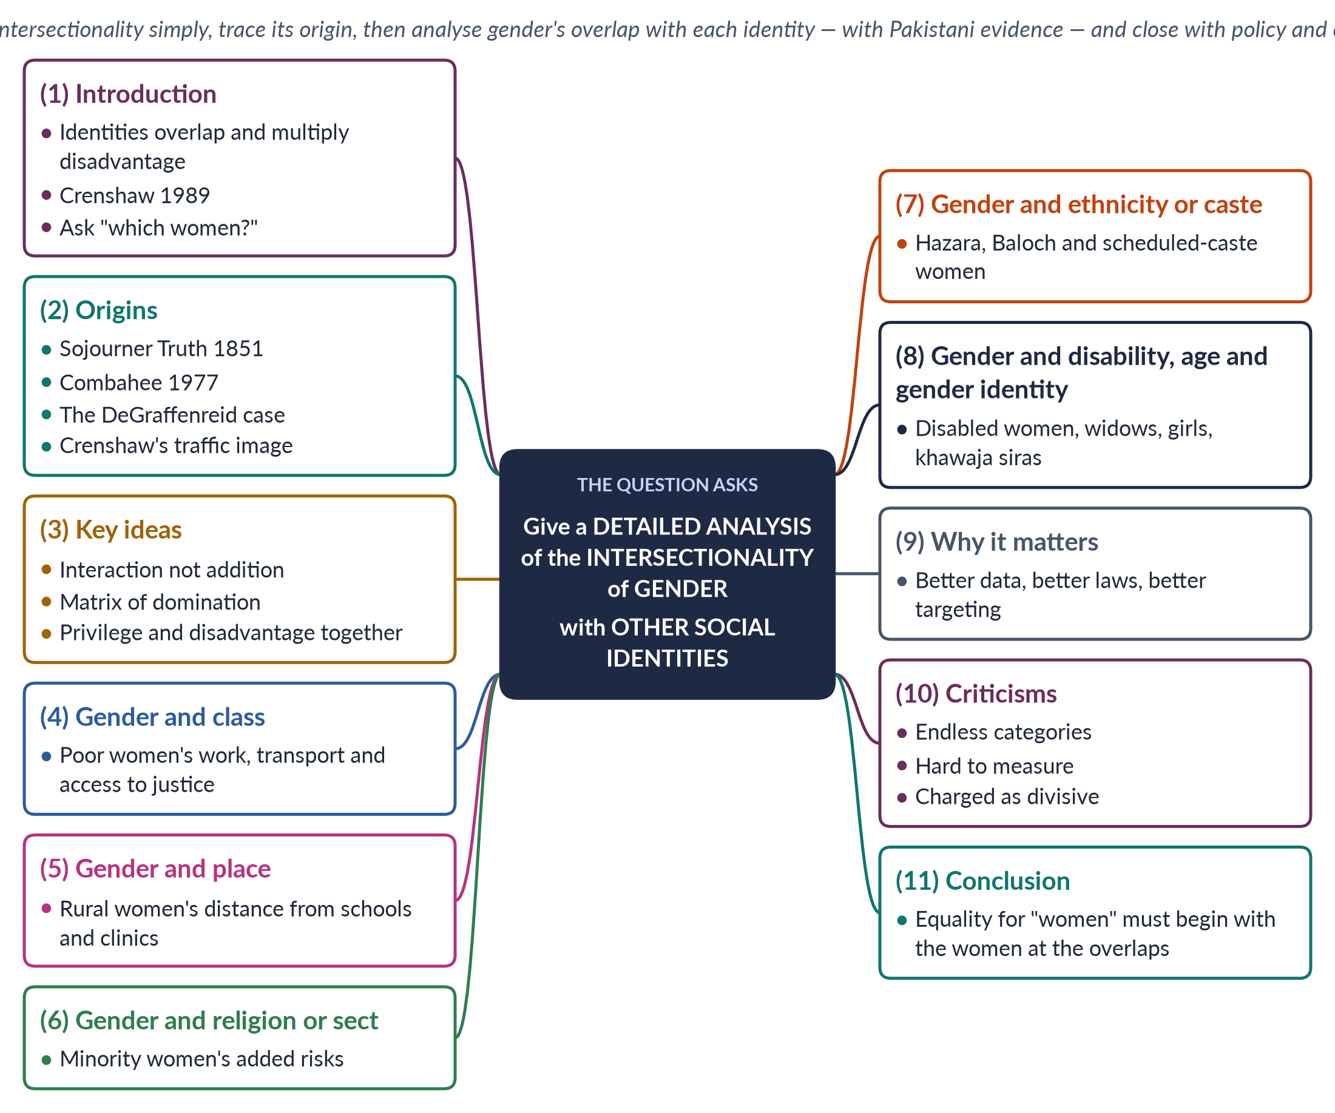
Figure 15 · The answer map: every branch is one numbered heading of the model answer below.

Decoding the question
"Give a detailed analysis" asks you to take the concept apart: what it means, where it came from, how it works, and what it shows. "With other social identities" tells you to go through several identities — class, place, religion, ethnicity, disability, age, sexuality and gender identity — and show how each interacts with gender. Pakistani evidence under each identity turns a textbook answer into an analysis.

The model answer

1. Introduction

i) Definition
Intersectionality is the idea that a person's social identities — gender, class, race, religion, ethnicity, caste, disability, age and sexuality — overlap and interact, producing unique experiences of privilege and disadvantage that cannot be understood one identity at a time.

ii) Origin of the term
The American law professor Kimberlé Crenshaw coined it in 1989. It grew from discussions on gender and race, but now covers every identity.

iii) The argument
Intersectionality is not a new school so much as a tool: before saying anything about "women", it asks "which women?" In a country as diverse as Pakistan, gender policy that ignores this question reaches the women who need it least.

2. Origins

i) Early voices
Sojourner Truth's speech "Ain't I a woman?" (Akron, Ohio, 1851) pointed out that the ideal of the protected "lady" never applied to enslaved Black women. The Combahee River Collective (1977) described interlocking oppressions experienced simultaneously.

ii) Crenshaw's case
In DeGraffenreid v. General Motors (1976), Black women laid off by GM sued for discrimination. The court said GM hired women (white women) and hired Black people (Black men), and refused to combine the claims. Black women fell between the categories of race and sex.

iii) The traffic image
Crenshaw compared discrimination to traffic at an intersection: a woman standing where two roads cross can be hit from either direction — or both.

3. Key ideas

i) Interaction, not addition
Disadvantages do not simply add up; they multiply and change each other. A poor woman does not face "sexism plus poverty" but a different situation: she cannot afford private transport, so she rides crowded buses where she is harassed.

ii) The matrix of domination
Patricia Hill Collins (Black Feminist Thought, 1990) described a matrix of domination — intersecting oppressions organised through structures, institutions, culture and personal life.

iii) Privilege and disadvantage together
The same person can be privileged in one identity and disadvantaged in another. An educated, upper-class Pakistani woman faces sexism, but she may employ a domestic worker who has no labour protection.
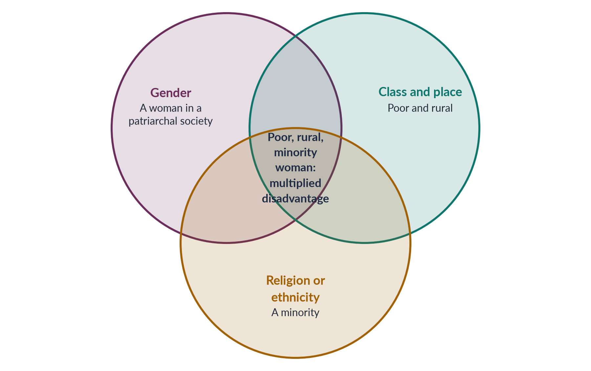
Figure 16 · Intersectionality: overlapping identities create a unique position.

4. Gender and class

i) Work
Female labour-force participation in Pakistan is 24.4% (LFS 2024–25), but the reasons differ by class. Poor women work, often unpaid or as home-based piece workers; middle-class women are often kept out of work by norms of respectability and unsafe transport.

ii) Justice
A poor woman facing violence cannot afford a lawyer, a phone or a bus to the court. Laws exist for all; access depends on class.

5. Gender and place (urban and rural)

i) Education and health
Female literacy is about 53% nationally (Census 2023), but far lower among rural women. Rural women live farther from schools, clinics and courts; the maternal mortality ratio of 186 per 100,000 live births (PMMS 2019) hides a sharper rural burden.

ii) Climate
In the 2022 floods, rural women in Sindh and Balochistan faced loss of livelihood, lack of privacy in camps and risks in pregnancy — gender, place and poverty together.

6. Gender and religion or sect

i) Minority women
Hindu and Christian women and girls face added risks, including reported cases of forced conversion and marriage, especially in Sindh and Punjab. Ahmadi women face both gender norms and legal and social discrimination against their community.

ii) Within the majority
Sect and interpretation also shape women's lives — for example, in access to mosques, inheritance practice and dress codes.

7. Gender and ethnicity or caste

i) Ethnic minorities
Hazara women of Quetta have lived with targeted attacks on their community; many are widows carrying both trauma and the burden of family survival.

ii) Caste
Scheduled-caste Hindu women in Sindh face poverty, bonded labour and caste prejudice alongside gender norms.

8. Gender and disability, age and gender identity

i) Disability
Women with disabilities face barriers of access, stigma and marriage prospects that neither disabled men nor other women face in the same way.

ii) Age
Girls face early marriage — Islamabad set a minimum age of 18 in 2025 — while widows and elderly women often lose property and support.

iii) Gender identity
Khawaja siras stand at the overlap of gender identity, poverty and exclusion; the Transgender Persons (Protection of Rights) Act 2018 and its court challenges show how contested their position remains.
Table 5 · How gender interacts with other identities in Pakistan.
Identity | What the overlap produces
Class | Unpaid and home-based work; no access to lawyers or safe transport
Place | Distance from schools, clinics and courts; climate risk
Religion | Reported forced conversions; community discrimination
Ethnicity or caste | Targeted violence; bonded labour; prejudice
Disability | Inaccessible services; stigma; marriage barriers
Age | Child marriage; widows' loss of property
Gender identity | Exclusion from family, work and inheritance

9. Why intersectionality matters

i) Better data
Averages hide the worst-off; data must be broken down by sex, place, class, disability and religion.

ii) Better laws and policy
Programmes must be designed for the women at the overlaps — for example, mobile health teams for rural women, legal aid for poor women, and protections for minority girls. The Benazir Income Support Programme, which pays poor women directly, is an example of targeting at the overlap of gender and class.

iii) A better movement
It keeps feminism from speaking only for the urban middle class — a criticism often made of Pakistan's women's movement.

10. Criticisms

i) Endless categories
Critics say the list of identities can grow forever, fragmenting the movement.

ii) Hard to measure
Multiplied disadvantage is harder to count than single categories.

iii) Divisive?
Some argue it divides people by identity; supporters reply that it reveals divisions that already exist. Crenshaw herself described it as a lens for seeing how power works, not a ranking of who suffers most.

11. Conclusion
Intersectionality shows that "women" is not one group. Gender interacts with class, place, religion, ethnicity, disability, age and gender identity to produce very different lives. For Pakistan — ranked 143rd of 145 in the Global Gender Gap Report 2026 — the lesson is practical: equality for women must begin with the women at the overlaps, or it will reach only those who need it least.

Why this answer scores
- The concept is defined simply, with its origin, case and image — the examiner sees understanding.
- Each identity has its own heading with Pakistani evidence — a true "detailed analysis".
- A Venn figure and a table show the overlaps at a glance.
- Why it matters and criticisms give balance, and the conclusion turns theory into policy.

